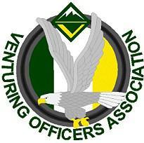
Ventures Officers Association

Meeting Minutes
July 25, 2018
Name: | Jasmin Williams, Secretary
Next meeting: | August 1, 2018, 7:00-8:30pm, Mandarin Library
- Attendees
Youth:
- Jadah F. President
- Mark W. VP of Admin
- Tyler G. Treasurer
- Jasmin W. Secretary
Adults:
- Ashley F.
- Todd G.
- Leann L.
- Officers’ Discussion: Led by Jadah Foltz
Intro: Meeting 7:00 p.m.
The End: Conclusion 8:30 p.m.

- Events and Upcoming Activities
- VSW
  - Budget complete
  - Bottle rockets(?)
  - Vinyl design on T-Shirt (pocket sixed)
  - Shooting Sports, Climbing Wall, Life Guards, Escape Room
  - Shirts will not be a part of budget
    - Talk at a later meeting
- Lead the Adventure Day
  - Parking, Check-in, and Crew Engagement
  - Games, songs, etc.
  - Crews that are going
    - 25
    - 225
    - 288
    - 645
    - 26

- Training Event
  - November 14th-16th
- Other Things
- Tyler: Work on operating budget
- VOA T-shirts
  - $18
- Jeramiah Italian Ice: Samples being served at LTAD; Full sized available if wanted but need money for.

