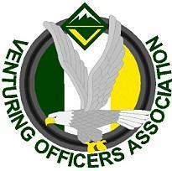
Ventures Officers Association

Meeting Minutes
November 24th, 2019
Name: | Sierra Crabtree, Secretary
Next meeting: December 8th | , 2019, 5:00-6:30pm,
- Attendees
Youth:
Jasmin W. President
Maya B. VP of Program
Ben C. Vp of Admin
Alan P. VP of Training
Sierra C. Secretary
Adults:
Ed P.
Todd G.
- Officers’ Discussion: Led by Jasmin Williams
Intro: Meeting 5:08
The End: Conclusion 5:49

- Events and Upcoming Activities

(Conference Call)
Kodiak
- Have selected a cook
- have planned pout schedule
- first 5 to register will receive a free water bottle
VSW
- Patches and shirt design in prorgress
- working on going to see the island again
- Need to look up some game ideas
Misc.
- December Lock-in
  - need to move to the weekend of the 13th

