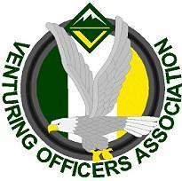
Ventures Officers Association

Meeting Minutes
October 27, 2019
Name: | Sierra crabtree, Secretary
Next meeting: | November 10, 2019, 5:00-6:30pm,
- Attendees
Youth:
Alan P VP of training
Maya B VP of program
Ben C VP of admin
Sierra C Secretary
Jasmin W President

Adults:
Bobbi M
Josh M
Ed P

- Officers’ Discussion: Led by Jasmin Williams
Intro: Meeting 5:10
The End: Conclusion 6:12

- Events and Upcoming Activities

training weekend
- let the teachers know where they are teaching at
- they have until Tuesday night to sing up for CPR and First aid

The University of Scouting
- need to find/recruit teachers
Kodiak
- need leaders to guide by this weekend

VSW
- Start working on the leader's guide
- Patch design

