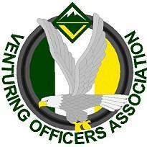
Ventures Officers Association

Meeting Minutes
October 13th, 2019
Name: | Maya Brown, Secretary
Next meeting: October 27th | , 2019, 5:00-6:30pm,
- Attendees
Youth:
Jasmin W. President
Ben C. VP of Administration
Taryn B. Treasurer
Alan P. VP of Training
Maya B. VP of Programs
Sierra Secretary
Ethan
Adults:
Josh M.
Leann L.
Jeff L.
Bobbi M.
- Officers’ Discussion: Led by Jasmin Williams
Intro: Meeting 6:52
The End: Conclusion 8:30

- Events and Upcoming Activities
Training Weekend
- Have All teachers
- Going to send materials soon
VSW
- Breaking up into a group
  - using colored bands
- need to plan a date to watch Gilligan’s Island
- 45 participant cap
Misc.
- Need to check days off
- southern council vsw like event
  - nov. 22-25
  - $20
- Christmas Lockin
  - 1st weekend of December
  - Universal?
- VOA Shirts
  - Shirts too dark
    - can do black design
    - can do a vinyl design in white
  - White shirts
- Winterfest
  - feb. 6th -9th
  - Gatlinburg Tennessee
  - 75-100 for hotel, 20 ish for food, 45 registration (10 adults)
- venturingfest
  - June
  - at summit
  - Kodiak challenge

